Meringue Cookies ("Forgotten Kisses")
Recipe courtesy Emeril Lagasse, 2003
Show: | The Essence of Emeril
Episode: | Meringues

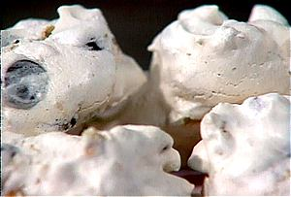
2 large egg whites, at room temperature
1/2 teaspoon cream of tartar
2/3 cup superfine granulated sugar
1 teaspoon vanilla extract
1 cup semisweet chocolate chips or finely chopped semisweet chocolate
1 cup finely chopped walnuts (optional)

Preheat the oven to 350 degrees F and line 2 baking sheets with parchment paper. Set aside.
You will have time and space to bake two cookie sheets only. You may pick these up after school or tomorrow in class.
- In the bowl of an electric mixer, beat egg whites until foamy.
- Add the cream of tartar and beat until fluffy but not at all dry. (Be careful not to over beat.)
- Add the sugar gradually, about 3 tablespoons at a time. When 1/2 of the sugar has been added, add the vanilla extract.
- Continue beating and adding remaining sugar in batches, until all of the sugar is dissolved and the meringue is very shiny and tight.
- Gently fold in the chocolate chips and the optional chopped nuts.
- Working one teaspoon at a time, push a teaspoonful of meringue from the tip of 1 teaspoon with the back of another teaspoon onto the lined baking sheets, leaving 1-inch of space between cookies.
- Place baking sheets in the preheated oven and turn the oven off. Leave the cookies (undisturbed) in the oven for at least 2 hours and up to overnight, or until cookies are crisp and dry.

